Trace Table for the Area
Part1: 03_area_m2.py
length = float(input ("Enter the length "))
width = float(input ("Enter the width "))
area = (length) * (width)
print ("The area is:", f" {area:.2f} m\u00b2 (square metres)")
Line | Statement | length | width | area | Output
1 | length = float(input ("Enter the length ")) | 5.5 | - | -
2 | width = float(input ("Enter the width ")) | 5.5 | 4 | -
3 | area = length * width | 5.5 | 4.0 | 22.0
4 | Print (…) | 5.5 | 4.0 | 22.0 | The area is: 22.00 m² (square metres)

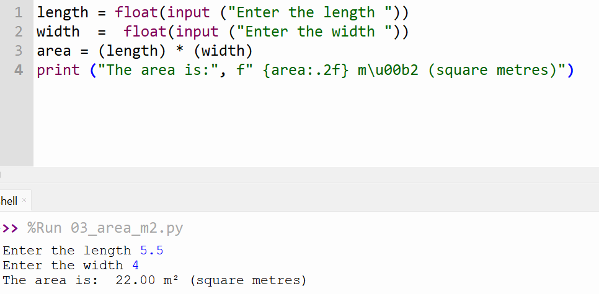
Trace Table for the averages
Part 2: 03_averages
mark1 = float (input ("Quiz Mark 1 :"))
mark2 = float (input ("Quiz Mark 2 :"))
mark3 = float (input ("Quiz Mark 3 :"))
mark4 = float (input ("Quiz Mark 4 : "))
average =( mark1 +mark2 +mark3 +mark4) / 4
print ("Average: ", f"{average: .2f}")
Line | Statement | Mark1 | Mark 2 | Mark3 | Mark 4 | Output
1 | mark1 = float (input ("Quiz Mark 1 :")) | 60 | - | - | -
2 | mark2 = float (input ("Quiz Mark 2 :")) | 60 | 70 | - | -
3 | mark3 = float (input ("Quiz Mark 3 :")) | 60 | 70 | 80 | -
4 | mark4 = float (input ("Quiz Mark 4 : ")) | 60 | 70 | 80 | 90
5 | average =( mark1 +mark2 +mark3 +mark4) / 4 | 60 | 70 | 80 | 90
6 | print(…) | 60 | 70 | 80 | 90 | 75.00

